Group-4
Book Management System

TEAM
129062 Pravin Arumugam (Group Lead)
129059 Bavya Anandkumar
129060 Pavithra Chenna
129061 Deva Martin Selvaraj
129063 Revathi Ramamoorthy
129064 Tejaswini Rajulapalli
129086 Thejasree Dommaraju

The following are the screenshots for the output of Forms and Reports for Book Management System:

- Books Database

- Books Upload Control File

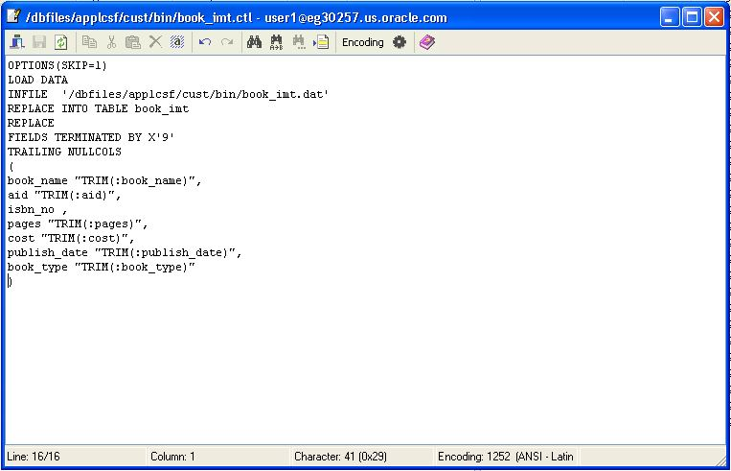

- Authors Database

- Authors Upload Control File

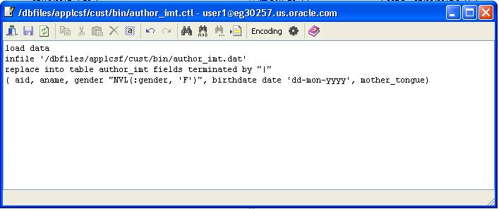

- Book Master Form

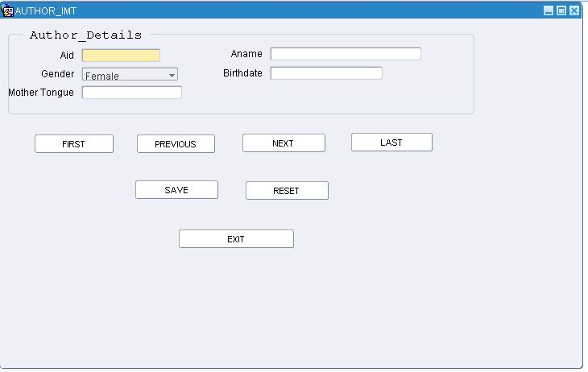

- Author Form

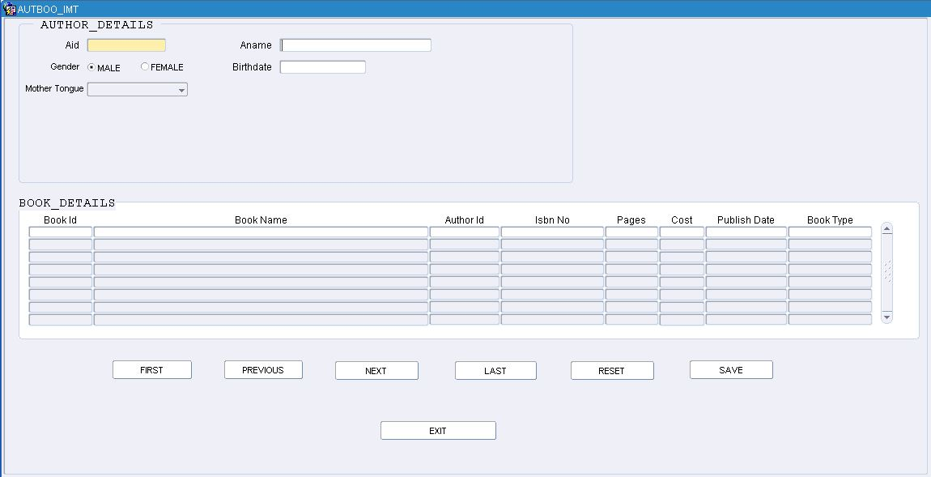

7. Report object navigator

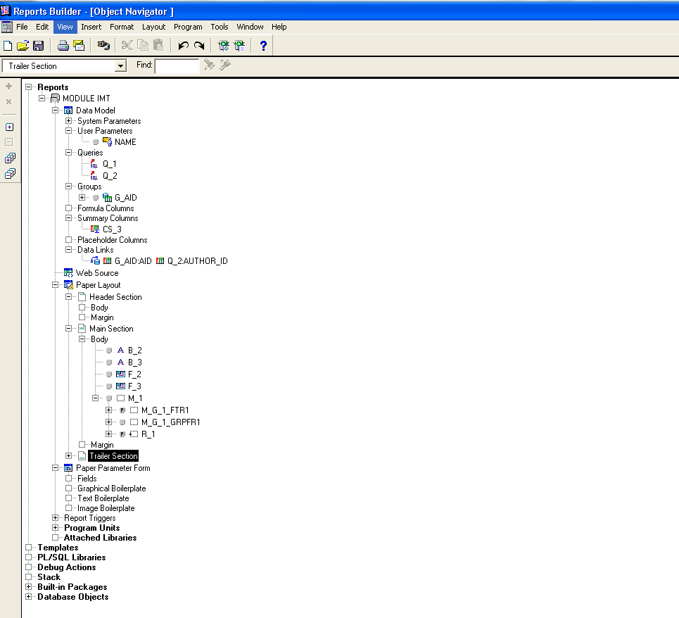

8. Report Data Model

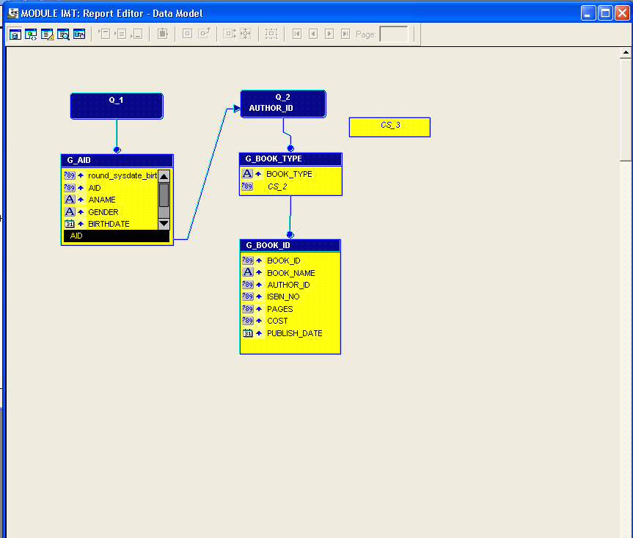

9. Paper Layout
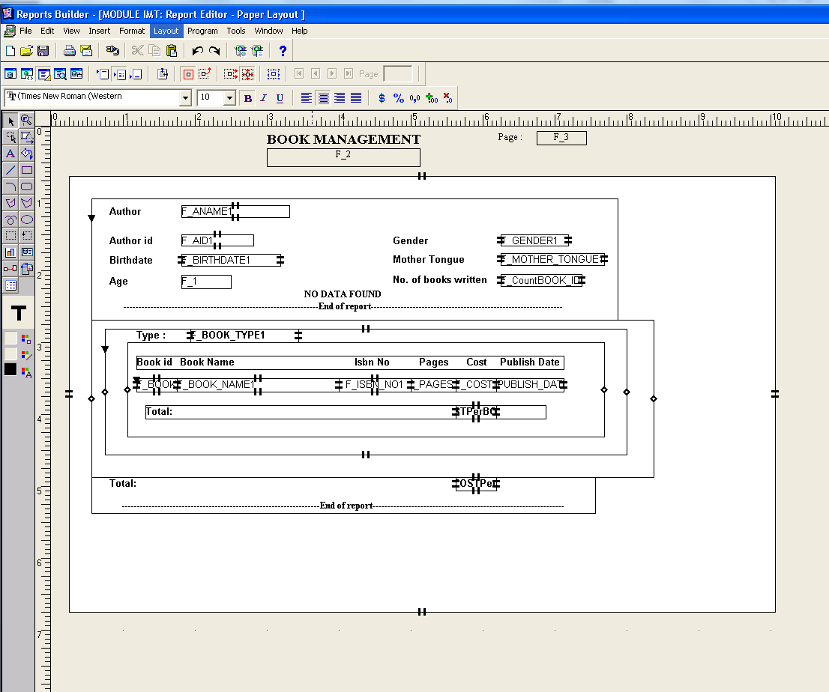

10. Report output for data found
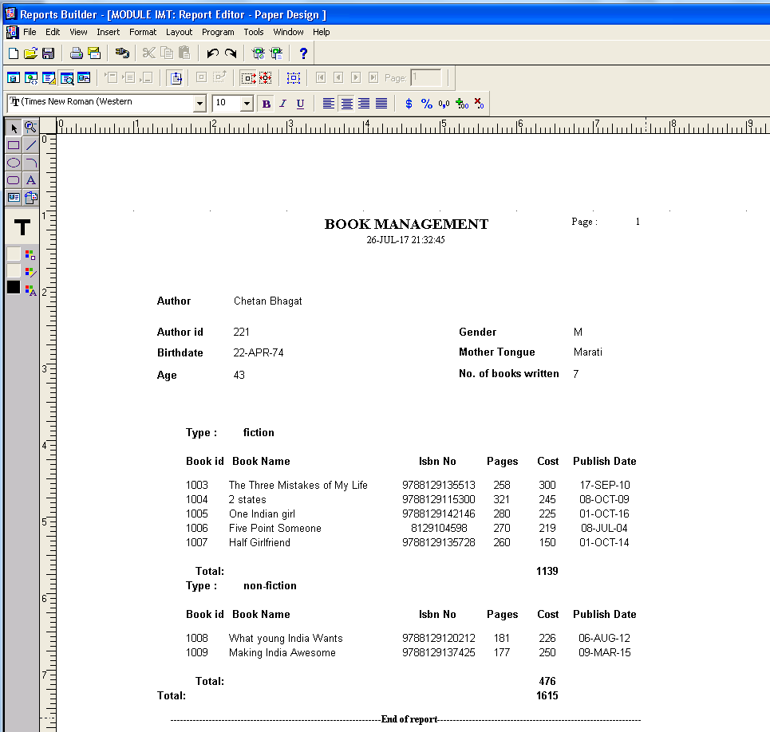

11. Report output for no data found
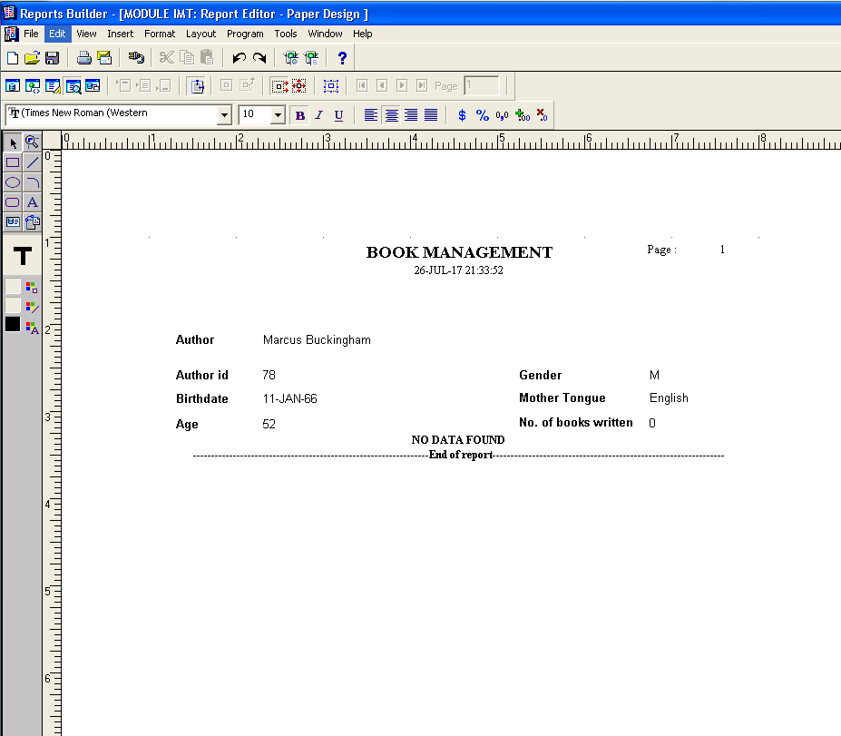

- Future-Scope – With Check-boxes for data filteration

